MATH 3P40 - Mathematics Integrated with Computers and Applications III

Assignment 3

Matt Laidman
5199807

March 13, 2017
Problem 1
A simulation of the ballistic deposition model using a lattice length of 10⁵ over 10⁸ iterations and plotting the interface width over time produces the following result:
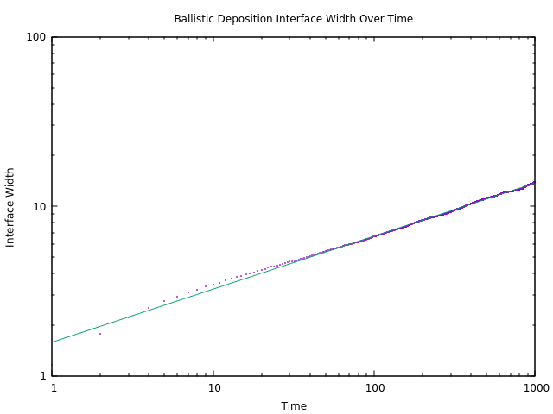
The curve fitting this data is given by:
where;
This gives a growth exponent value, β, of about 0.31 – a very close approximation to the expected value,
Problem 2
Simulations of the ballistic deposition model on the parameters below were run, and the plots of their interface widths over time again were plotted. These plots have been included at the end of this problem solution. The saturation values for these simulations were estimated by fitting a horizontal line to the second half of the data. A summary of the data is below.

Lattice Length | Iterations | Saturation Value (α)
50 | 50000
100 | 150000
200 | 450000
400 | 1350000
800 | 4050000
1600 | 12150000
3200 | 36450000
6400 | 109350000

Plotting the lattice length against the estimated saturation value produces the following:
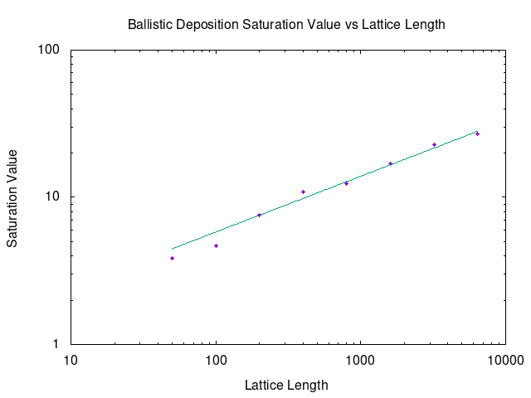
The line fitting this data is given by:
where;
Giving a resulting approximate value of 0.378362 for the roughness exponent.
This value is significantly lower than the expected value of as only 8 simulations were run, and each was only run once. Running a larger number of simulations and each simulation multiple times so that the average could be plotted, the average interface width at each time step would have very little fluctuations and therefore give a more accurate result.
Plots:
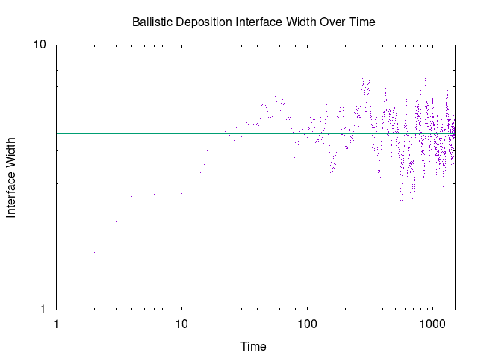L = 100
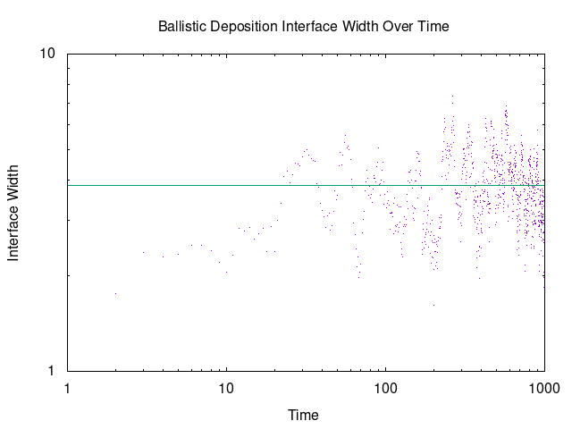L = 50

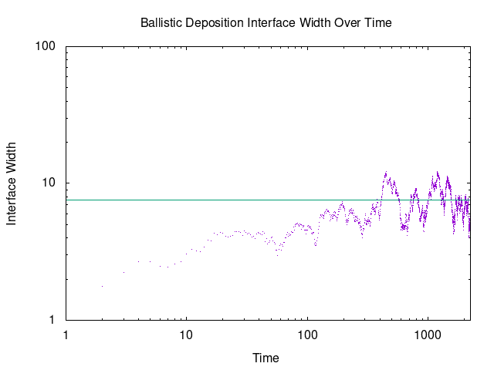L = 200
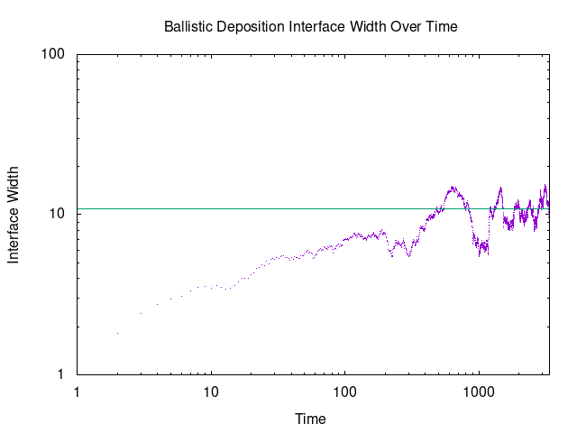L = 400
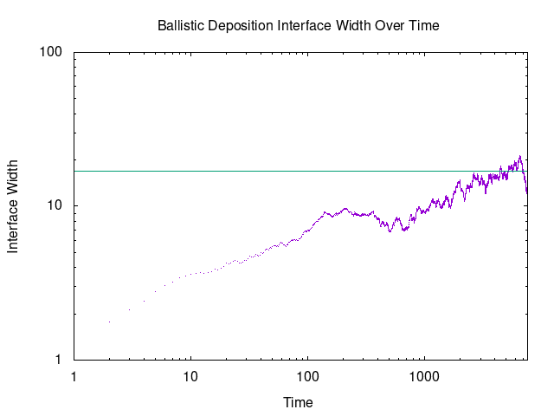L = 1600
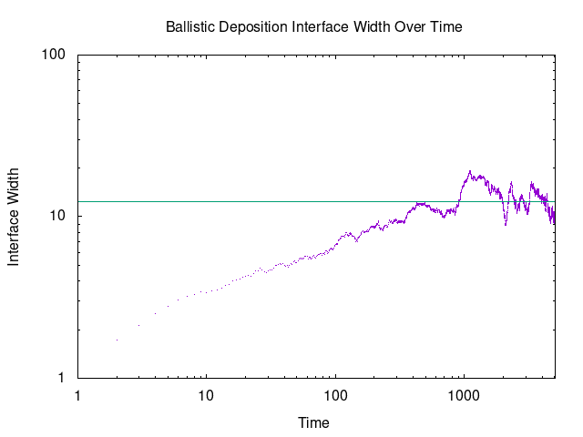L = 800
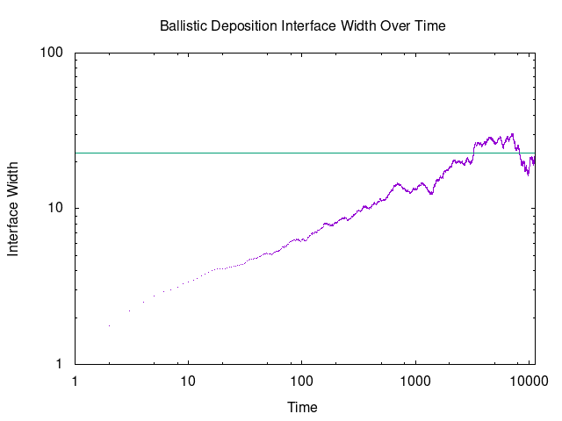L = 3200
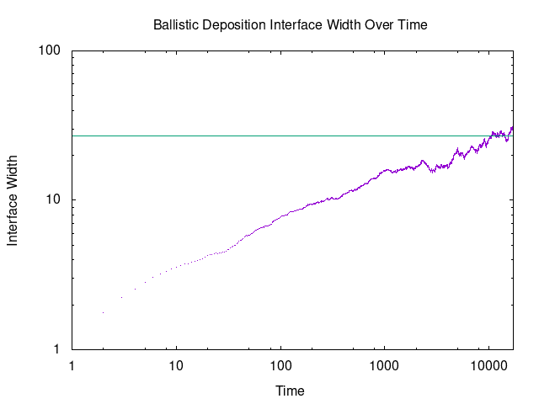L = 6400
Problem 3
Using the scaling relation, the value for z is given by:

However, this is of course not equal to the expected value of
The uncertainty of the result can be estimated by multiplying the nominal value for z by the sum of the relative errors of α and β. That is:

